Parents and Guardians,

We have many resources you can access to allow learning to continue at home. They are the following: Google Classroom, 3rd/4th Grade website, Lexia and ST Math. If you’re able to access Google Classroom and the 3rd/4th Grade website, your student will be able to access ST Math and Lexia without a problem.

The 3rd/4th grade website is mpmorse.weebly.com learning games and other links can be found here.

Each day we are out of school, your student’s teacher will post something new to the Google Classroom entitled Online Learning. This is going to be your best resource to help learning continue throughout the closure. Codes for your student’s classroom are as follows:

Mr. Morse/Ms. Davis: zsagypw
Mrs. Walton: yjc2ch4

To access Google Classroom follow these steps:
1. On any internet enabled device, go to classroom.google.com OR download the Google Classroom App

2. Sign in with your student’s own Granite School District account which can be figured out as follows:

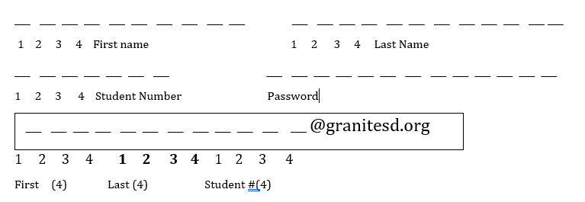

Your student should know how to fill out the form above with their first name, last name and 9 number. In the box, your student should have the first 4 letters of their first name, the first 4 letters of their last name, and the first 4 digits of their nine number with @granitesd.org at the end. That is now your student’s login. They should know their password as it is the same one we use at school.

We realize this could be confusing so if you have any questions or concerns, please email our school computer specialist, Mr. Pope at rpope@graniteschools.org
To continue to stay connected with your student’s teacher, please sign up for the Remind app. It’s a great way to quickly contact your student’s teacher to get updates and any information you may need to successfully learn at home. Your student’s teacher should have invited you to sign up in the last week. Codes to sign up for Remind are as follows:

Mr. Morse: @mrmorsescl
Ms. Davis: @4c6eg4
Mrs. Walton: @k442b

Text your teacher’s code from above to the following number: 81010

You may also email your student’s teacher. Emails are as follows:

Mr. Morse: mmorse@graniteschools.org
Ms. Davis: madavis1@graniteschools.org
Mrs. Walton: flwalton@graniteschools.org

Thank you for all your time and support! Please let us know if you have any questions or concerns! Stay safe and healthy these next couple weeks!

Mr. Morse
Ms. Davis
Mrs. Walton

